OIL PRODUCTION USING ARTIFICIAL LIFT SYSTEMS
Student Name
Institution
Course Name/Number
Due Date
Instructor Name

PROJECT DESCRIPTION
Team Sigma Consultancy firm in Gas and Oil seeks to solve the rise in energy demand that comes with less hydrocarbons for every tent exploration by enabling the production of oil wells with effective production and management techniques. The end-goal is to accommodate the increasing energy demand. The major technique as per the view of the company is to introduce artificial lift production methods that help in role in assisting dead wells, liquid loaded wells and non- flowing oil wells to restore their oil production states. Artificial lift is used when reservoirs do not have enough energy to naturally produce oil to the surface or at the desired economic rate. The basic concept of artificial life is to add energy to the fluid column in a well bore in order to create a predetermined bottom hole pressure so the reservoir may produce the objective flow rate (Kermit, 1982). Artificial lift is used for two purposes: to induce flow in naturally dead wells and, more commonly, increase/maintain flow rate in already producing wells. As artificial lift can start, accelerate and increase recovery from a reservoir, it is widely used.
The scope of this project is to conduct a comparative study of the performance sucker rod and ESP lifting system on a producing oil well data in the Niger Delta using a prosper software for the design and simulation. This work will be highly significant to the oil and gas operators, as well as the production engineers, especially those operating in the Niger Delta region where issues like water breakthrough leads to early liquid loading which in-turn affects production rate followed by a decline in the oil flow rate and adverse economic in return.

CANDIDATE SELECTION
The factors that determine the most viable method for the artificial lift techniques are well geometries and fluid properties among other technical factors. The most commonly used artificial lift systems are:

Electrical submersible pumps.
It is the second most widely applicable A.L.S with over 100,000 operating pumps worldwide. The technology consists of switchboard, junction boxes, wellhead, power cables, gas separator, protector and motors. Other popular modifications include the use of variable speed-drives (V.S.D).
The ESP performance description uses characteristic pump performances plots. These plots show the relationship between the pressure rise (head) and flow rate through the pump, the horsepower requirements and the pump efficiency, all for a certain rotational speed. The plots are created by the pump manufacturer based on tests with water as test fluid. Usually for a multistage pump only one pump stage is displayed in such a plot. 90% of all oil-producing wells need artificial lift. The electrical submersible pump (ESP) came as an artificial lift system in 1927. Today ESPs are the second most common artificial lift method, with over 100,000 pumps operating globally.
The ESP consists of a centrifugal pump mounted on an electrical motor. Centrifugal pump increases their fluid pressure by changing the kinetic energy since they are dynamic components. They have ESP applications are mostly in multistage pumps with small diameters and many stages. This design makes them useful for smaller wellbores because of their ability to increase high-pressure. They range from low-medium viscosity when handling liquids, ranging from low to medium viscosities. Their performance is characterized by the relationship between pump’s flow rate and the increasing pressure for various rotational speeds. This relationship is usually shown in characteristic pump performance curve plots. The performance curves are based on tests done by pump manufacturers using water as test fluid.
The advantages and disadvantage of ESP operations below the perforations are presented by Wilson et al. (1998). Several equipment options for this type of operations are presented. Solutions to the problem with insufficient motor cooling are discussed thoroughly. A case study of a field where below perforation operations have been successful is also presented. Wilson concluded that the natural annular separation of gas, got in below perforation operations, will minimize gas interference in the pump. Further, he concluded that as long as the production rate is limited to keep the reservoir saturated, there will be no advantages in locating the ESP below the perorations. This type of operation should only be considered in cases where there is need to increase the production.
The factors involved in selecting the E.S.P are
- ESP motor performance; speed, specific gravity when filled working with mineral oil. Dielectric strength to prevent short-circuit of motor parts, lubrication with bearings, thrust-bearing support for rotors, cooling availability based on fluid velocities,
- ESP protector ratings; housing and drive shaft specification, thrust bearing ability to absorb axial thrust, isolation chamber dimensions, plane bearing support for high-thrust loads and ability to operate with lubrication oils.
- ESP Gas separator; pump performance speficifications, temperature and pressure effect to ESP pump with heat developed, high flow-rate, pump mechanical damages.
- ESP cable requirements; hydrocarbon’s presence, aggressive fluid environments, high temperature, diameter to fit with annulus along well tubings, protection against mechanical damages during pulling and running the cables.
- Surface equipment; presence of positive seals around the tubing and cables, maintaining tubular controls.
- Variable Speed drive operation; flexibility speed comparison with artificial lifts, system efficiency, electric operational frequency.
- Through-Tubing ESP; unique latching device specifications, rig requirements, reservoir access, solid’s tolerances, operational costs, oil rates, rig workovers, pump life, ESP deployment methods, corrosion, integrity of tubing components.

Sucker rod (beam) pumps.
The selection criteria for Sucker Rod pumps involve;
- Bottom-hole pressure. A small ratio between the two increases the oil rate of production.
- Counterweight placement.
- Pump conditions; fluid pound, tubing movement, pump hitting, sticking pump, bent barrel, gas interference, split, valve and plunge leakages
- Rod string stresses i.e. either lateral and longitudinal waves of rod elements.
- Solid sensitivity
- Efficiency in Gassy wells.
- Depth contribution from rod capacities.
- Rod grade sizes; different corrosion specifications, threads.

.
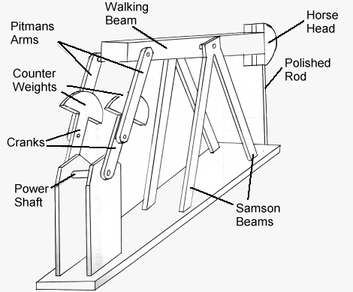
Figure 1.1 detailed schematics of a typical beam-pump installation.
The general factors that determine the selection of Artificial Lift systems are;
- Well geometry; Azimuth angle and Dogleg severity that affects the system reliability with the wear between sucker rods and tubing. The dog-leg severity affects the integrity of power cables with seals and engines.
- Gas Handling; PCP and SRP volumetric efficiencies, mechanical/ natural gas separation, heterogenous pressure distribution.
- Fluid compatibility; stator’s elastomer ability to work with wellbore fluids.
- Flow rate flexibility; capability to handle the vast rate of oil production with lack of design alteration in the sub-surface or surface installations.
- Production uncertanities; ability to prevent the pump-off conditions through increasing the liquid’s flow rates, downhole temperatures & pressures, motor failures modificaitons.
- Well depth; ability to handle the increasing hydraulic horsepower, limitations of maximum mechanical capacities (sucker rods), injection pressures and transmitted power.
- Down-hole temperatures; effect of elastomer’s swelling rates, mechanical degradation, cable and motor’s dielectric properties, material’s temperature resistance, compatibility test conditions.
- Solids handling; management of sand production from wells using superficial pumps while mitigating the stability conditions.
- Slim Hole wells; outer and inner casing diameter dimensions and its relation to pump and motor transmission.

ECONOMIC ANALYSIS
In 2020, the size of market for Artificial Lift system increased to $10B registering around 7% of the Compound Annual Growth rate expected of this industry between 2021-2027. The increasing investments towards subsea exploration comes from the trend of accepting unconventional oil reserves that has direct impact to the business growth. The optimization and expansion of these wells also creates an enterprise scenario for the players of the industry. Therefore, this increased growth has a direct impact to the oil consumption and technology advancement that boosts the production demands.
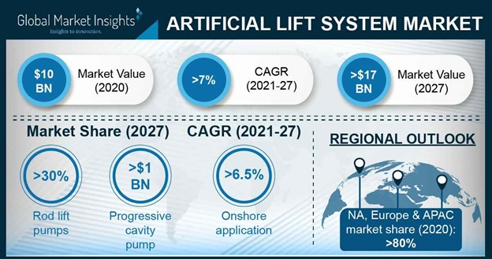
Figure showing the $10B Market value of Artificial Lift System.
In a study comparing Mexico, Argentinam Angola, Algeria, Iran, Turkey, Kuwait, UAE Oman, Saudi Arabia, Malaysia, Thailand, Indonesia, India, Chin, Ukraine, Azerbaijan, Russia, Turkmenistan, Kazakhstan, Netherlands, Norway, UK, Canada and the United states it highlighted a $17.4B projected value of this Artificial Lift systems in 2027 (Ankit and Abhishek, C. (2021). The significant economic drivers of this technology are; growing crude oil demand, increased subsea production, trend shifting from unconventional wells and increase in numbers of matured wells.
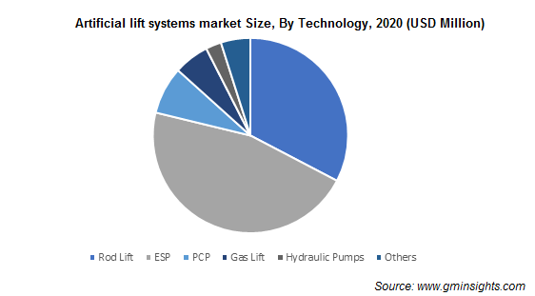
Figure showing the Size of the Market Size by technology of Artificial Lift Systems.
The estimated Market Share of A.L.S is that it has a value equal to $1B as of 2027 as for Progressive Cavity Pump (P.C.P) making it the leading technology. Others such as E.S.P, Rod Lift, Gas lift, Hydraulic pumps for onshore and offshore areas propelled with crude oil price. The increasing demand for crude oil for countries including that of Egypt, Kuwait and Saudi Arabia indicated an increase in the business outlook mainly because of PCP technology. The methods have a higher efficiency, accurate metering, improved suction pressures, reduced backflow, lower cost of maintenance. The E.S.P technology that follows as the next technology facilitates robust growth for aging and matured wells for petroleum product demands that translates to the A.L.S market trends.

REFERENCES
Ankit. G, and Abhishek, C. (2021). Artificial Lift systems market sizes by technology. Industry Analysis Reports. Accessed on 9th May 2020. Retrieved from Artificial Lift Systems Market Analysis | Industry Share 2021-2027 (gminsights.com)
Deng, L., Davani, E., Darabi, H., Suicmez, V. S., & Castineira, D. (2018, November). Rapid and comprehensive artificial lift systems performance analysis through data analytics, diagnostics and solution evaluation. In SPE Middle East Artificial Lift Conference and Exhibition. Society of Petroleum Engineers.
Kolawole, O., Gamadi, T. D., & Bullard, D. (2020). Artificial Lift System Applications in Tight Formations: The State of Knowledge. SPE Production & Operations.

